# Report: Z drive closing file explorer after a period of time

**Tickets related:**

<https://itsdterracat.zendesk.com/agent/tickets/306877> - David Willets - March – When the issue was first raised

<https://itsdterracat.zendesk.com/agent/tickets/309428> - David Willets - April

<https://itsdterracat.zendesk.com/agent/tickets/313008> - David Willets - May

<https://itsdterracat.zendesk.com/agent/tickets/317931> - Michael O’kane - July

CRC team

Z:\\ad.ggh.co.nz\CRC

**Troubleshooting done:**

* “sfc scannow” command

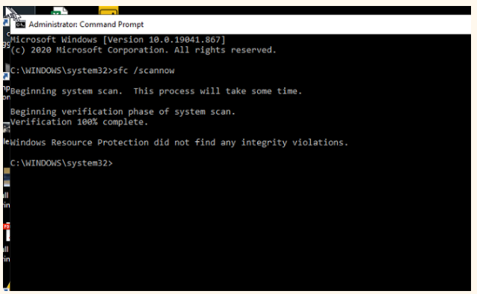

* “chkdsk” command

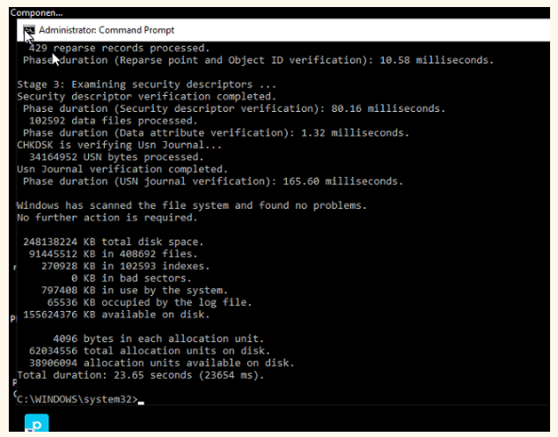

* Deleted the 2 “bag” folders in registry in the below **shell** folder

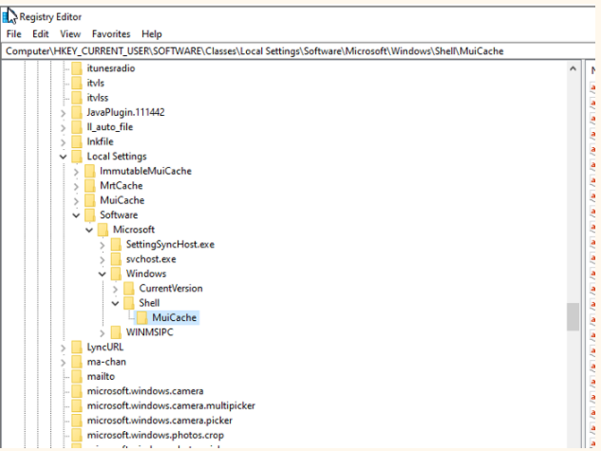

* Ran the “netsh winsock reset” command

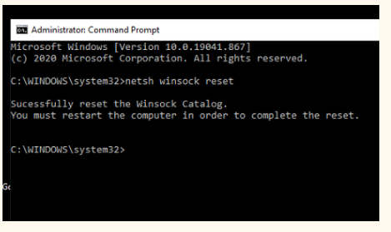

* Updated graphics driver
* Ticked this setting in file explorer

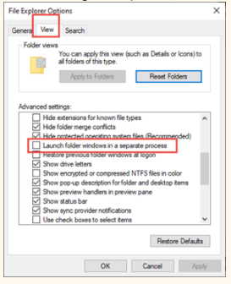

* New laptop was given but issue still remained
* Tested Z drive on my computer by putting me in all the AD groups associated with it – confirmed that file explorer does in fact close on its own – in July when I tested it, it closed itself within 10-15 mins. Now it closes after a couple of hours.
* Manually mapped it to a different letter – works fine
* Grabbed David’s password so that I could physically test out his account on another laptop without being on the phone to him and disrupting his workday. Opened File Explorer on Z drive, navigated to a few folders, minimised File Explorer then waited for it to close itself down. Tried it a few times, the last test started at 12.38pm 13/10/2021 – closed down at 2.03pm with error message in event viewer

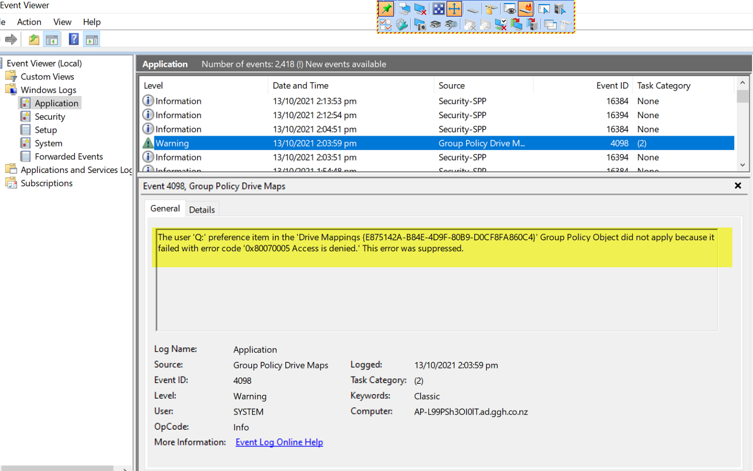

* Decided to manually map the drive to the letter Y, started the test again at 3.14pm 13/10/2021 – was still open when I arrived to work at 7am 14/10/2021

**Findings:**

AD groups associated:

* CRC Admin
* CRC Drive PC Group
* CRC Job Files Folder
* CRC Management
* CRC Technician

Group Policy groups:

* CRC Drive PC Group
* UserCRC
* GGHSIS

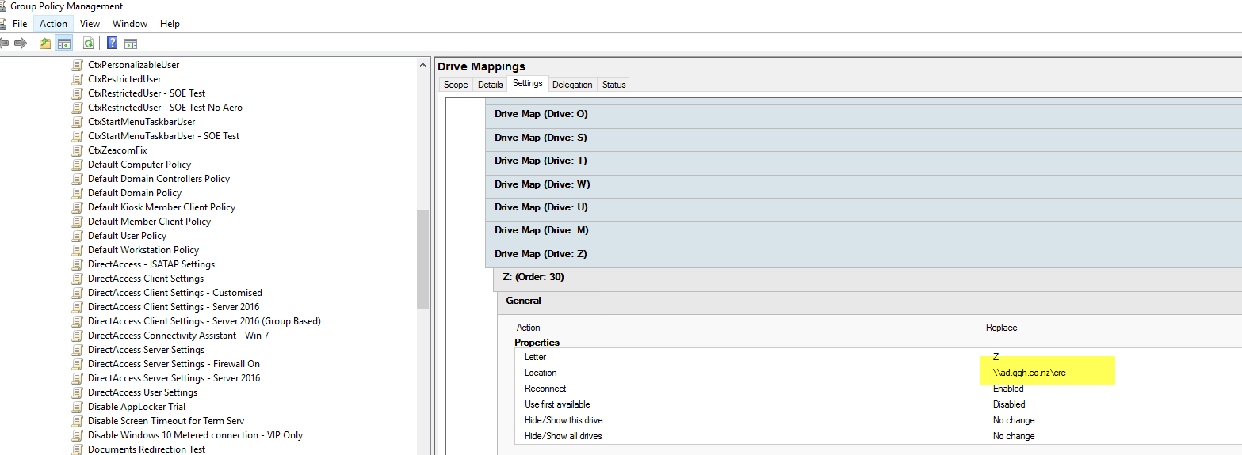

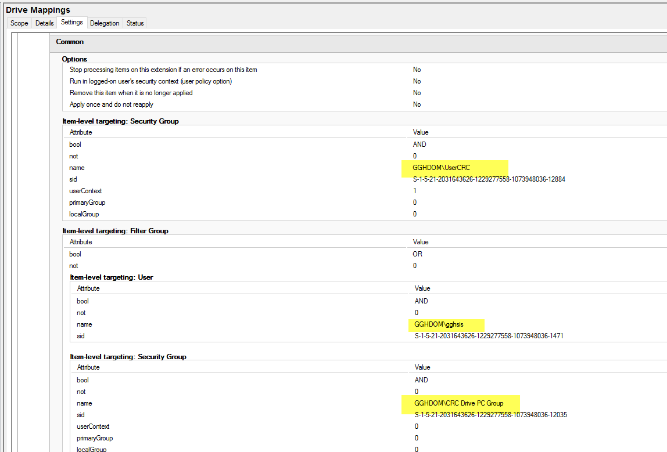

Error message in event viewer (image further above)

Works fine when manually mapped to another letter

**Research:**

<https://social.technet.microsoft.com/Forums/en-US/dc6db0a7-207a-499b-ab2a-4fa4246b93ac/file-explorer-closes-randomly?forum=win10itprogeneral>

<https://social.technet.microsoft.com/Forums/azure/en-US/06c53d39-4807-4c5c-b37b-b0f39e4bf79d/group-policy-user-drive-mapping-is-set-to-update-how-to-disconnect-while-keeping-update-setting?forum=winserverGP>

